Technical report

1. Team members, GitHub links and app links:
Sam Day (23850695)
Sol Manners (23817634)
GitHub link: https://github.com/samnday-debug/six-seasons-app
App link: https://six-seasons-app-awbfbytcjbwthdz4aknk9w.streamlit.app/

2. What we built and who it is for.
The project is an interactive weather and Noongar seasonal knowledge web application designed to help users explore the relationship between current weather conditions, and the six Noongar seasons. The application is being developed to provide live weather information alongside published knowledge about Noongar seasons, including flora, fauna and environmental indicators associated with different times of the year.
The intended audience is people who want to learn more about Noongar seasonal knowledge and the environmental changes that occur throughout south-west Western Australia. Users will be able to explore the six seasons, view associated plants and animals, and compare this information with current environmental conditions.
Cultural information used within the application is sourced from recognised organisations and published resources rather than being generated by the development team or artificial intelligence.

3. Architecture and data flow.
The application is organised into separate components for preparing data, performing calculations and displaying information. The data preparation script combines three Bureau of Meteorology (BOM) files into one daily weather dataset. The seasons.py module loads the seasonal information, assigns weather records to seasons and calculates averages and trends. The app.py file provides navigation between four views, which present the results to users. A separate weather.py module requests current conditions, hourly forecasts and seven-day forecasts from Open-Meteo. The ui.py module provides shared styling for Today, Season Explorer and Trends. This structure allows users to continue exploring historical information when live weather is unavailable.

Figure 1.
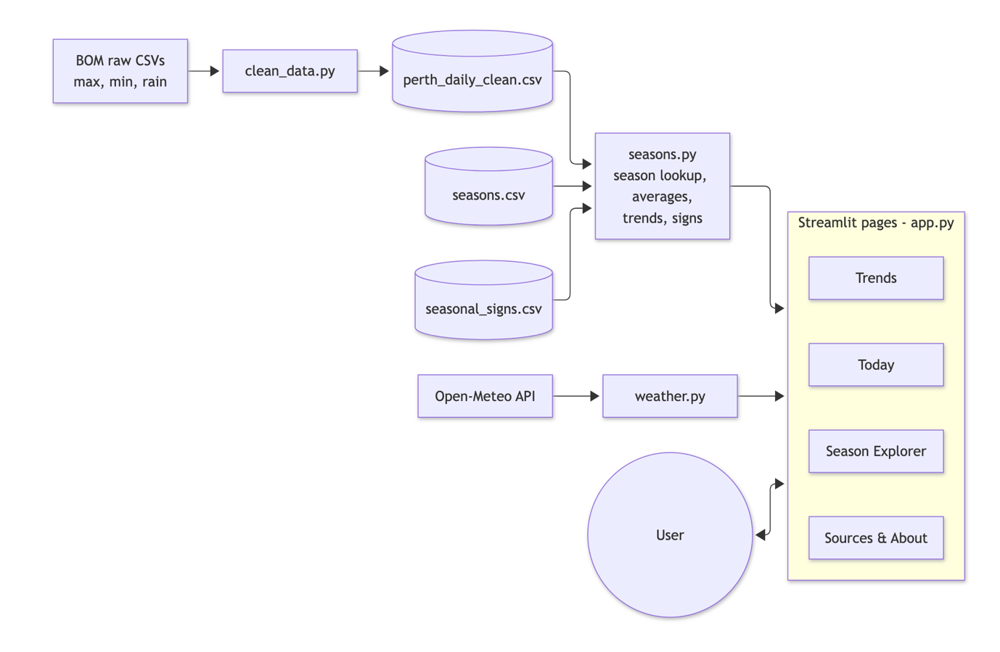
Figure 1. The main application components and the movement of data between them. User selections control the information displayed. Streamlit stores loaded results temporarily and reuses live weather responses for ten minutes, reducing repeated requests and calculations.

4. Algorithms and technical decisions.
The application identifies the current season using month ranges stored in seasons.csv. The months_in_season function advances through these ranges using modulo arithmetic, allowing December to continue into January. The data-loading process checks that all twelve months are covered exactly once. The season_for_date function checks that its input is a date before returning the matching season. The application uses Perth local time so that a server located in another time zone does not cause the wrong date to be displayed.
Historical weather records are grouped by season and season year to support comparisons over time. December is assigned to the following season year, so December 2024 and January 2025 are both included in Birak 2025. This approach prevents one season from being divided between two calendar years. A dictionary connects month numbers with season names, and pandas groups the resulting records. Temperature measurements are averaged, while rainfall measurements are added together. Groups containing fewer than 55 recorded dates are excluded from seasonal rainfall summaries and annual trend calculations.
The main numerical algorithm calculates a straight line of best fit using the least-squares method. It first calculates the mean year and mean weather value. The slope is then calculated by dividing the sum of the products of their deviations from these means by the sum of the squared year deviations. The intercept is calculated from the mean value and the slope. Multiplying the slope by ten gives the change per decade displayed in the application. The calculation is implemented directly rather than delegated to a regression library, making its steps available for explanation and testing. Processing time increases linearly with the number of observations. The function rejects fewer than two points or identical year values, while the interface requires at least five qualifying seasons.
During development, an updated species CSV caused the Season Explorer to fail because combined season names and a revised column heading were not recognised. The loading process was updated to match alternative spellings with the application’s main season names and to accept both description headings. It also removes surrounding spaces and ignores differences in letter case. Alternative spellings for the same season produce one entry, while an entry associated with two different seasons is displayed in both. Unrecognised names continue to produce an error. This change allows the application to use the edited dataset while maintaining consistent filtering and links between seasons.

5. Data source and preparation.
The historical weather dataset is sourced from BOM Climate Data Online for Perth Airport, station 009021 [4]. Separate files contain daily maximum temperature, minimum temperature and rainfall. The preparation script constructs dates and combines the files so that a date is retained when it appears in any source. Blank accumulation periods are treated as one day, while measurements covering several days are marked as missing. Days without any measurements are removed. The script also checks for duplicate dates and reports cases where minimum temperature exceeds maximum temperature. Individual missing readings remain missing rather than being estimated.
The prepared dataset contains 30,108 records covering 1 May 1944 to 5 October 2026. The application begins its analysis on 1 January 1945, using 29,863 records and meeting the minimum requirement of 200 records. The full dataset contains 65 missing maximum temperatures, 110 missing minimum temperatures and nine missing rainfall readings. Original quality indicators are retained. A total of 3,921 maximum-temperature, 3,924 minimum-temperature and 1,222 rainfall values have quality N, indicating that they have not yet been quality-checked. These values remain in the analysis, which is a limitation when interpreting the results.
Season definitions and species information are loaded from separate CSV files. BOM’s Nyoongar calendar supplies the published seasonal framework [5]. The source list identifies City of Stirling, Marine Waters and Noongar Boodjar plant and animal resources for seasonal signs [7–9]. Open-Meteo supplies current conditions, hourly forecasts and seven-day forecasts [6]. Source identification is present, but the repository still has unfinished licence and copyright notes. Source-specific usage conditions and attribution must be completed before submission; public availability alone does not establish permission to reuse material.

6. Analysis and visualisation.
The application analyses daily weather measurements to provide seasonal temperature averages, average seasonal rainfall totals and annual comparisons. Season Explorer presents season cards and a details window containing historical weather averages and recorded flora and fauna. The earlier species-count bar chart has been removed. A two-ring calendar allows users to compare the six Noongar seasons with the four European seasons.
Table 1.
Season | Mean max °C | Mean min °C | Mean rain mm
Birak | 30.7 | 16.1 | 20.5
Boonaroo | 30.9 | 16.8 | 31.4
Djiran | 23.8 | 11.7 | 133.8
Mookaroo | 18.5 | 8.5 | 307.7
Djilba | 19.5 | 8.5 | 191.0
Kambarang | 24.5 | 11.6 | 68.7
Table 1. Outputs from the current dataset and season_summary function. Temperatures average available daily readings from 1945 onwards; rainfall averages totals from season-year groups passing the 55-date threshold. The two calculations therefore do not use identical completeness rules.

The calculated results show that Mookaroo has the highest average seasonal rainfall total, while Boonaroo has the highest average maximum temperature. These comparisons help users identify differences in the weather recorded at Perth Airport. The Boonaroo maximum-temperature series includes 82 qualifying seasons and shows a fitted increase of approximately 0.23 °C per decade. This result describes the linear pattern within the available dataset. It does not establish the cause of the change or demonstrate statistical significance.
The Trends view allows users to select a season, weather measure and year range. A line chart displays the annual results, with an orange dashed line representing the calculated trend. Users can inspect individual values through tooltips and view the change per decade, overall average and number of included seasons in summary cards. Presenting the annual observations alongside the trend allows users to compare year-to-year variation with the longer-term pattern.

7. Interface and user experience
The interface provides four views, meeting the requirement for at least three distinct screens. The Today view displays the current date and seasonal summary, followed by a blue weather panel showing current temperature, feels-like temperature, forecast high and low, rain chance and forecast rainfall. An hourly strip presents upcoming forecasts, while a seven-day table shows daily conditions, temperatures and rainfall. Times use Perth local time, and unavailable measurements are shown as a dash. Season Explorer provides a current-season banner and six season cards with buttons that open a details window containing separate flora and fauna tabs. The Trends view provides labelled selection controls and a year slider for exploring historical changes. Sources & About identifies the information sources and explains how the weather data were prepared.
Today, Season Explorer and Trends share blue accents, rounded panels and consistent spacing through ui.py. The application uses sidebar navigation, information cards and chart tooltips to help users find and interpret information. Sources & About retains its existing layout. The current season is highlighted, and species entries identify other seasons containing the same scientific name. Warning messages explain when live weather is unavailable or when a selected year range contains too few seasons for a trend. A typical user task involves opening a season, viewing associated species and average weather, and then exploring changes in its maximum temperature. Formal usability and accessibility testing with the intended audience has not yet been documented.

8. Testing and limitations
Testing is used to check the main application functions, calculations and responses to invalid input. The existing repository contains 20 pytest cases. Eight additional regression cases were added locally to check the revised CSV loading process, resulting in 28 passing cases in the corrected working copy. The latest inspected GitHub upload includes seasons.py only, so the additional tests still need to be committed. Local Streamlit checks also confirmed that Season Explorer and all six seasonal details windows opened successfully. The deployed correction was subsequently confirmed working during development.
Table 2.
Area | Evidence from checks
Calendar and grouping | Twelve-month coverage; December-to-January wrap; boundary dates; next-year Birak grouping.
Numerical calculations | Exact-line slope and intercept; rejection of too few points and identical years; incomplete rainfall group exclusion.
Invalid input and failure | Non-date input, overlapping season definitions and unknown names are rejected; simulated network failure returns None.
CSV regression checks | Six label scenarios, old description-heading support and the uploaded dataset with the dolphin in two seasons.
Table 2. Test coverage. Passing these checks verifies the tested behaviours, not every possible input or external service response.

The calendar currently uses fixed month ranges. It does not infer a season from environmental observations, and regional variation is not modelled. The weather series represents one station and is not a complete account of south-west WA. Linear fits do not include uncertainty intervals, significance tests, station-change adjustments or causal analysis. The 55-date threshold is an approximation: it counts date rows rather than valid measurements for each metric. Missing rainfall can reduce a total without causing exclusion, and temperature summary means include available days from partial seasons. These limitations should be addressed before presenting the analysis as a rigorous climate assessment.
The Today view labels a value “Rain today”, but that value is taken from Open-Meteo’s daily precipitation forecast field. Daily maximum and minimum values are also forecast outputs, so clearer labels should distinguish these from current conditions and observed totals.

9. Security and privacy
The application does not provide user accounts or forms for collecting personal information. Weather requests use fixed coordinates for Perth Airport rather than requesting a user’s location, and the current implementation does not require an API key. Selection menus and sliders limit the values users can enter through the interface. Shared banner text is escaped before being displayed as HTML. The loading functions check season coverage and names, while the trend calculation checks for inputs that would prevent a valid result. Live weather requests use a ten-second timeout and handle network or response errors by displaying an availability warning.
These measures address risks associated with a small educational application, although a comprehensive security audit has not been performed. Malformed data files may still prevent a view from loading, and dependency versions are not fixed in requirements.txt. Hosting and weather providers may also process technical connection information independently of the application. Further improvements include clearer data-validation messages, regular dependency review and continued checks that passwords or other credentials are not added to the repository.

10. Deployment
The application is deployed through Streamlit Community Cloud, allowing users to access it outside the development environment. The app.py file is the entry point, and the repository contains the required Python modules and datasets. The requirements.txt file identifies Streamlit, pandas, Altair and requests as dependencies. Instructions for local installation and testing are provided in the README, although the repository address in its clone command remains a placeholder. Historical information is loaded from the included CSV files, while the Today view requires an internet connection to request weather updates.
The CSV loading correction was uploaded in commit 3eea768 on 7 October 2026, after which the live application was confirmed working. The latest prepared update contains ui.py, weather.py and revised Today, Season Explorer and Trends pages. It also retains the species-chart removal and missing-source caption fix. All five files must be uploaded together, with ui.py and weather.py in the repository root and the page files in views. Further deployment work includes checking the live app after upload, specifying dependency versions, completing the README installation command and committing the additional tests. The historical BOM dataset currently ends on 5 October 2026 and requires a separate update process. Refreshing live weather does not extend the historical dataset.

11. Team contribution
Sam Day was responsible for the application code and deployment. He downloaded the BOM daily data for Perth Airport and developed the cleaning script that merges maximum temperature, minimum temperature and rainfall files, removes empty days and checks for invalid readings. He developed the core logic in seasons.py, including season lookup, grouping December with the following January for Birak, seasonal averages and the least-squares trend calculation. He built the initial four Streamlit pages, Open-Meteo weather integration, season wheel and Trends view.

Sam also set up the GitHub repository, resolved merge conflicts, wrote and ran automated tests, and deployed the application to Streamlit Community Cloud. Deployment work included resolving private-repository access and server timezone issues. He used Claude to assist with writing and debugging code, then checked the implementation by running it, comparing outputs with expected values and testing failure cases such as an unavailable internet connection.

Sol Manners researched and prepared the initial cultural information, flora and fauna spreadsheet, seasonal information document and report outline. He subsequently revised species entries and descriptions, source references and formatting. Sol also coordinated later improvements, including the CSV loading correction, removal of the species-count chart, correction of missing-source labels, hourly and seven-day forecasts, and consistent styling across the main views. These changes were checked locally. He also revised the technical report to reflect the updated application.

References
[1] Day, S. and Manners, S. (2026). Six Seasons Perth project repository and commit history. Reviewed through commit 3eea768 on 7 October 2026. https://github.com/samnday-debug/six-seasons-app
[2] University of Western Australia (2026). CITS1501 Introduction to Programming with Python project brief. Supplied project.pdf. Assignment requirements and assessment criteria.
[3] University of Western Australia STUDYSmarter (n.d.). Writing a Report. Supplied A6-Writing-a-Report.pdf. Guidance on report structure and presentation.
[4] Bureau of Meteorology (n.d.). Climate Data Online. Daily observations for Perth Airport, station 009021; project snapshot ending 5 October 2026. https://www.bom.gov.au/climate/data/
[5] Bureau of Meteorology (n.d.). Nyoongar calendar. Published seasonal framework listed in the application. https://www.bom.gov.au/resources/indigenous-weather-knowledge/indigenous-seasonal-calendars/nyoongar-calendar
[6] Open-Meteo (n.d.). Weather Forecast API. Current and daily weather requested by weather.py. https://open-meteo.com/ API endpoint: https://api.open-meteo.com/v1/forecast
[7] City of Stirling (n.d.). Native Plants and Habitats. Listed by the application as a seasonal-sign resource. https://www.stirling.wa.gov.au/waste-and-environment/natural-environment-and-conservation/native-plants-and-habitats
[8] Marine Waters (n.d.). Fact Sheet The Noongar Six Seasons. Listed as a source for seasonal information and associated signs. https://marinewaters.fish.wa.gov.au/resource/fact-sheet-the-noongar-six-seasons/
[9] Noongar Boodjar Language Cultural Aboriginal Corporation (n.d.). Noongar Boodjar Plants and Animals. Atlas of Living Australia profiles, listed as a plant and animal reference. https://profiles.ala.org.au/opus/noongar

